A

**Progress Report**

On

# “KNIT KART”

Submitted by

**Arshil Amaan Ansari** (22709)

**Rahul Saini** (22742)

**Rakesh Kumar** (22743)

**Shantanu Saini** (22751)

**S**ubmitted to

**Prof. Babu ram  
Prof. Sonam Arya**

In

# Master of Computer Application

At



Department of Computer Science & Engineering

**Kamla Nehru Institute of Technology, Sultanpur**

Affiliated to Dr. A.P.J. Abdul Kalam Technical University, Lucknow

May, 2024

**INDEX**

|  |  |  |
| --- | --- | --- |
| **S. no.** | **Contents** | **Page No.** |
| 1. | Introduction | 3 |
| 2. | Survey | 5 |
| 3. | Design | 6 |
| 5. | Implementation | 9 |
| 6. | Conclusion | 11 |

**INTRODUCTION**

KNIT KART is an innovative platform designed to empower hostellers by providing an avenue to exchange unused items for things they need or monetary value. Going beyond traditional classifieds, KNIT KART fosters a circular economy within hostel communities, reducing waste and creating a sustainable and collaborative living environment.

**Problem Statement**

Hostel environments pose challenges in efficiently facilitating item exchanges among residents due to limited storage and frequent transitions. Existing platforms like OLX.in focus on monetary transactions and individual ad listings, not meeting hostel communities' unique needs.

This project aims to fill this gap by creating KNIT KART, a platform promoting direct item swaps, community engagement, and sustainable practices within hostels. Challenges include limited avenues for direct item exchanges, lack of community features in existing platforms, and inefficient resource use due to the absence of a specialized exchange platform.

To address these, KNIT KART will develop a platform fostering community, enabling direct exchanges, and promoting responsible consumption among hostel residents.

**Objectives**

The KNIT KART project stems from a multifaceted set of objectives aimed at addressing prevalent challenges in traditional classified platforms and fostering sustainable practices within hostel communities.

* **Reduce Unused Items:** The primary goal is to diminish the surplus of unused yet valuable items in hostel rooms. By encouraging users to exchange these treasures, KNIT KART contributes to minimizing waste and promoting a circular economy.
* **Facilitate Resourceful Exchanges:** KNIT KART aspires to go beyond the conventional model of selling items for money. It introduces a unique concept of facilitating exchanges, allowing users to acquire what they need in return for items they no longer use.

**Target Audience**

The initial focus of KNIT KART is on a specific demographic, namely hostellers. However, the platform is designed with scalability in mind, envisioning potential expansion to a broader audience in the future.

* **Hostellers:** KNIT KART caters to the unique needs of hostel residents, providing them with a tailored solution to exchange items, fulfil their requirements, and contribute to a sustainable and collaborative living environment.
* **Future Expansion:** While hostellers constitute the primary target audience during the initial phases, KNIT KART aims to extend its reach beyond hostel communities. The platform’s design and functionality are adaptable, laying the groundwork for potential expansion to the public domain.

**SURVEY**

Through personalized interactions, we conducted a survey among hostellers to understand their needs. Existing platforms like OLX.in were examined, revealing limitations in their ad-centric approach. KNIT KART emerged as a solution, enabling users to acquire what they need by trading items they no longer use.

**Comparison with Existing Solutions**

Several websites, such as OLX.in, provide services akin to KNIT KART. While these platforms excel in enabling users to post ads and request monetary compensation, they often fall short in fostering a sense of community and encouraging item exchanges. The pros and cons of such platforms were analysed:

**Pros of Existing Platforms**

* **Wide User Base:** Established platforms boast a large and diverse user base, providing extensive visibility for posted ads.
* **Monetary Transactions:** Smooth processes for monetary transactions simplify the exchange of goods for cash.

**Cons of Existing Platforms**

* **Limited Exchange Model:** Current platforms primarily focus on cash transactions, neglecting the potential for users to exchange items directly.
* **Anonymity Concerns:** The lack of community engagement features may result in anonymous transactions, missing opportunities for building trust and camaraderie among users.

**DESIGN**

The design of KNIT KART is meticulously crafted, aligning with modern design principles to ensure a visually appealing, interactive, and user-friendly experience.

**Design Principles**

* **Visual Appeal:** KNIT KART prioritizes visual appeal through the utilization of modern design principles and captivating colour schemes. The interface is crafted to enhance engagement and provide an aesthetically pleasing environment for users.
* **Interactive Elements:** To maintain user engagement, KNIT KART incorporates various interactive elements throughout the platform. Animated features and dynamic components are seamlessly integrated to create an immersive and enjoyable user experience.
* **Readability:** Focusing on the F-shaped pattern reading, the design ensures effective comprehension for users. Clear and concise typography, along with strategically placed elements, contributes to an interface that is not only visually appealing but also easy to navigate.

**Technologies Utilized**

* **CSS Modules:** KNIT KART employs CSS Modules to enhance code organization and maintainability. This technology enables the isolation of styles, preventing conflicts and simplifying the development and maintenance of the platform's visual elements.
* **Tailwind CSS:** Tailwind CSS is utilized to streamline the styling process. By leveraging its utility-first approach, KNIT KART achieves a more efficient and flexible design implementation, allowing for rapid development and easy customization.
* **ShadCN UI:** The platform integrates ShadCN UI to leverage its robust UI components. This ensures consistency in design elements and facilitates the creation of a cohesive and visually unified user interface.

The combination of these design principles and technologies contributes to the creation of an interactive and visually appealing platform that enhances the overall user experience on KNIT KART.

**E-R Diagram**

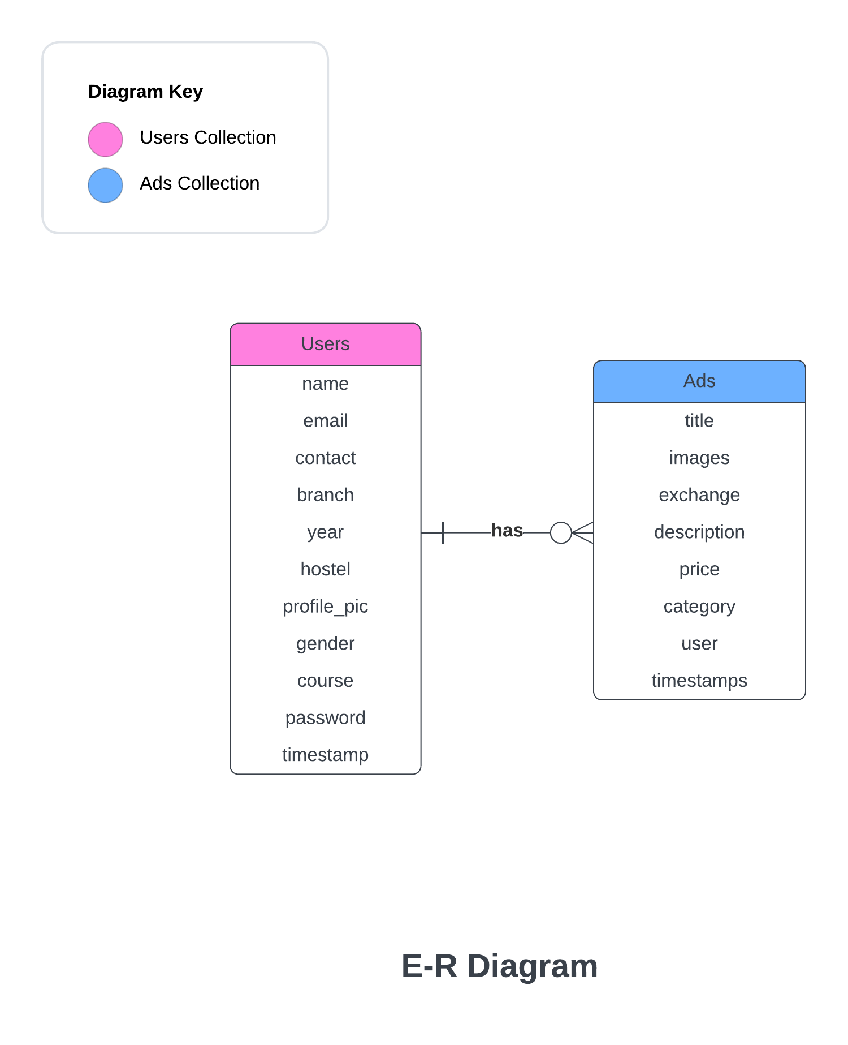

**Use Case Diagram**

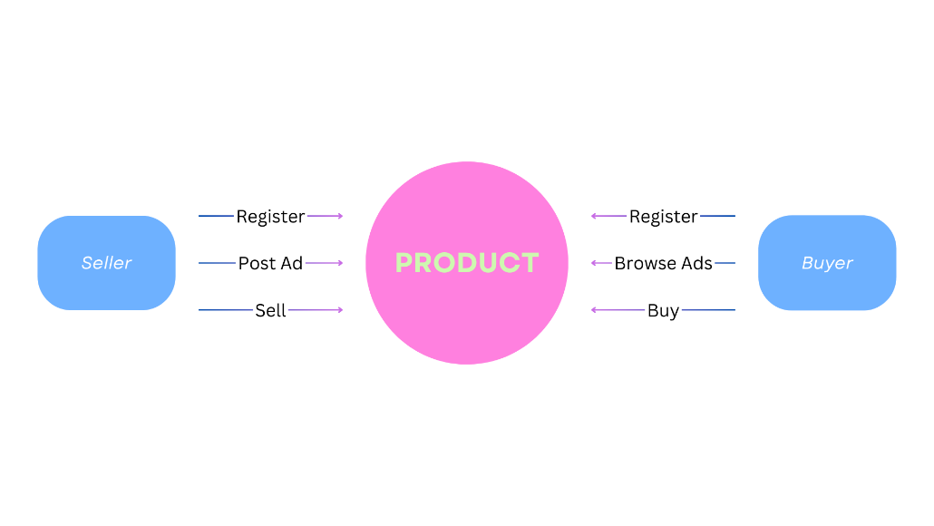

**Activity Diagram**

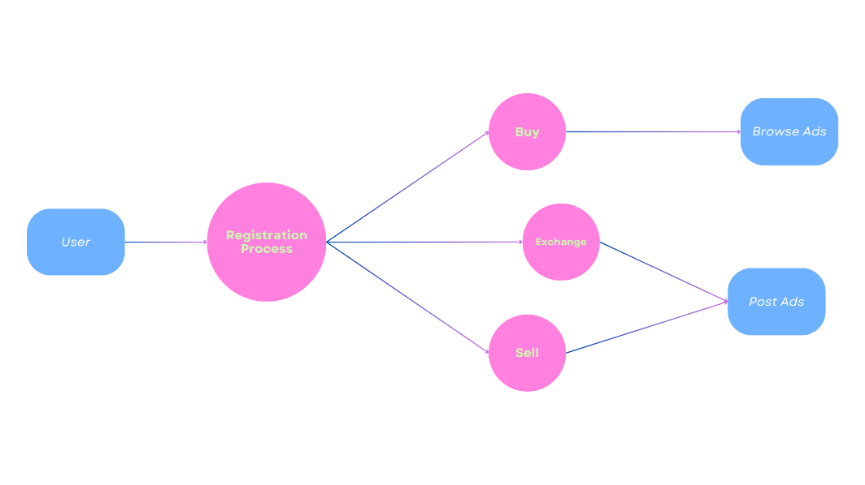

**DFD level 0**

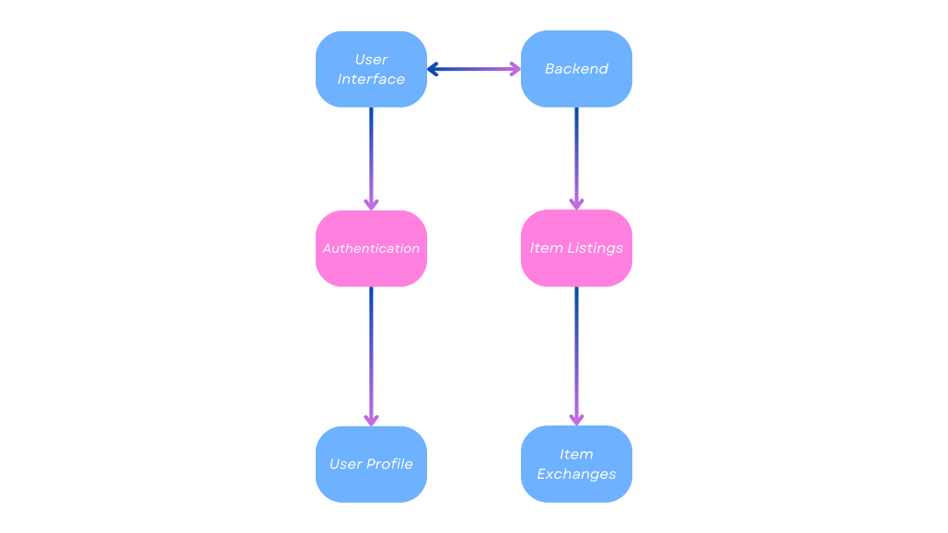

**IMPLEMENTATION**

The successful implementation of KNIT KART has been marked by a commitment to industry best practices, collaborative teamwork, and the strategic resolution of challenges encountered throughout the development process.

**Challenges Faced**

* **Feature Development:** Crafting and implementing a range of features required a comprehensive approach, addressing functionality, user experience, and technical feasibility.
* **Integration Complexity:** Overcoming challenges associated with integrating various components and technologies to ensure seamless functionality and user interaction.
* **Scalability Considerations:** Anticipating and addressing potential scalability challenges to accommodate a growing user base and evolving platform requirements.

**Learnings**

* **Collaborative Development:** The implementation phase underscored the importance of collaborative development. Effective teamwork and transparent communication were key factors in achieving project milestones and ensuring a cohesive final product.
* **Iterative Development Approach:** Embracing an iterative development approach proved essential. Regular feedback loops, continuous testing, and incremental updates allowed for agile responses to evolving project requirements.
* **Adaptive Problem Solving:** Implementing KNIT KART revealed the value of adaptive problem-solving. Quick and effective solutions were devised for unexpected challenges, ensuring minimal disruptions to the development timeline.

The implementation of KNIT KART has not only resulted in the realization of a feature-rich platform but has also provided valuable insights into effective development strategies and collaborative problem-solving approaches.

**Hardware Requirements**

* **Server Requirements:**
* CPU: 64-bit, quad-core processor with a minimum clock speed of 2.5 GHz per core.
* RAM: 4 GB or more.
* Storage: Minimum 20 GB of available space or more for hosting application files and data.
* **Cloud Hosting:**
* The platform should be hosted on a cloud platform such as AWS (Amazon Web Services) or Vercel for scalability and accessibility.
* Ensure sufficient CPU, memory, and storage capacity on the cloud servers to handle concurrent user requests and database operations efficiently.
* **Client-side Requirements:**
* Display: Dual XGA (1024×768) resolution or higher for optimal viewing experience.
* Web Browsers:

KNIT KART should be compatible with the latest versions of popular web browsers, including but not limited to:

* + Google Chrome
  + Mozilla Firefox
  + Microsoft Edge
  + Apple Safari

Specific browser versions supported may vary but should generally align with browsers that support modern web standards and technologies used in the frontend application (React.js).

**CONCLUSION**

Milestones achieved in development highlight KNIT KART's journey. As the platform enters user adoption, strategies focus on community engagement and continuous improvement. KNIT KART is not just a platform; it’s a dynamic ecosystem committed to sustainability and positive user experiences, with plans for future expansion beyond hostel communities.